THE GOLDEN CITY HOTEL
Functions with a view

Thank you for your enquiry regarding functions at the Golden City Hotel. We have two newly renovated function rooms, the Balcony and the Aviary, available to accommodate for your special function. We will work with you to design the most memorable experience for your event with us while sustaining your budget expectations.

Balcony

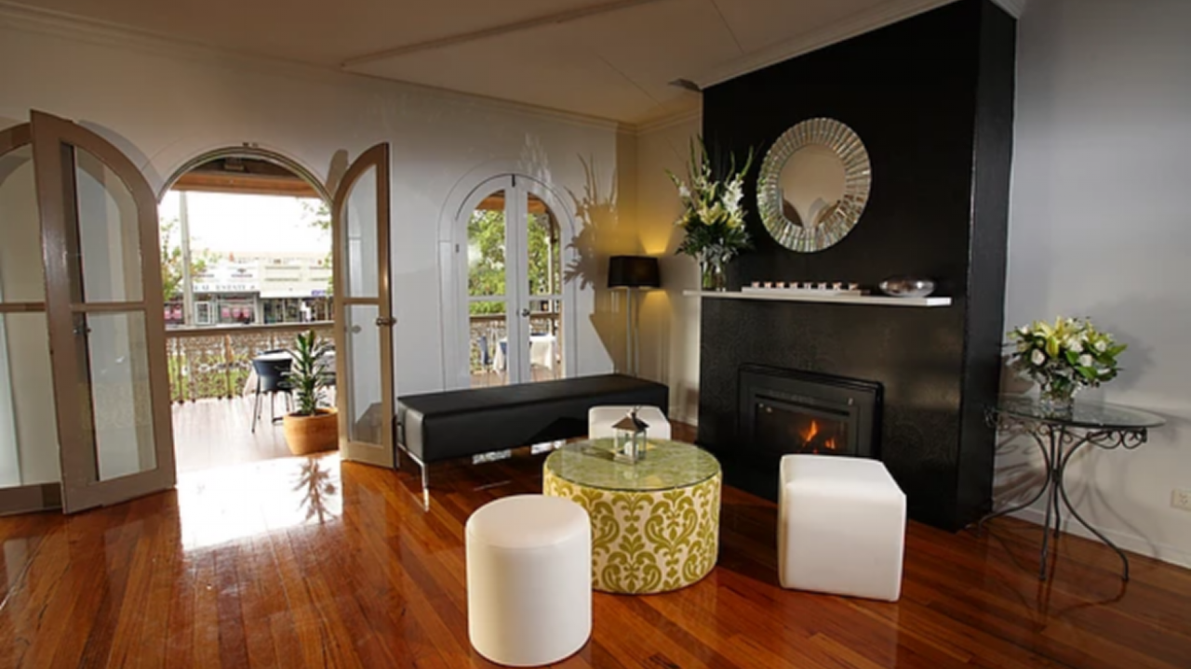

This beautiful space has been refurbished with a decor to suit small intimate weddings and the ability to have both ceremony and reception. We can also cater for large celebrations more suited for a cocktail style evening. It is fully equipped with a bar and balcony which overlooks Ballarat’s main street and gardens and has the capacity to hold up to 150 guests.

What is included:
- Full private access to room and balcony
- Live bands or DJ’s welcomed
- Professional bar/wait staff for your event
- Your selection of food & bar delivered to your expectations
- IPod connectivity & AV equipment and additions required
- Set up and clean up provided

Aviary

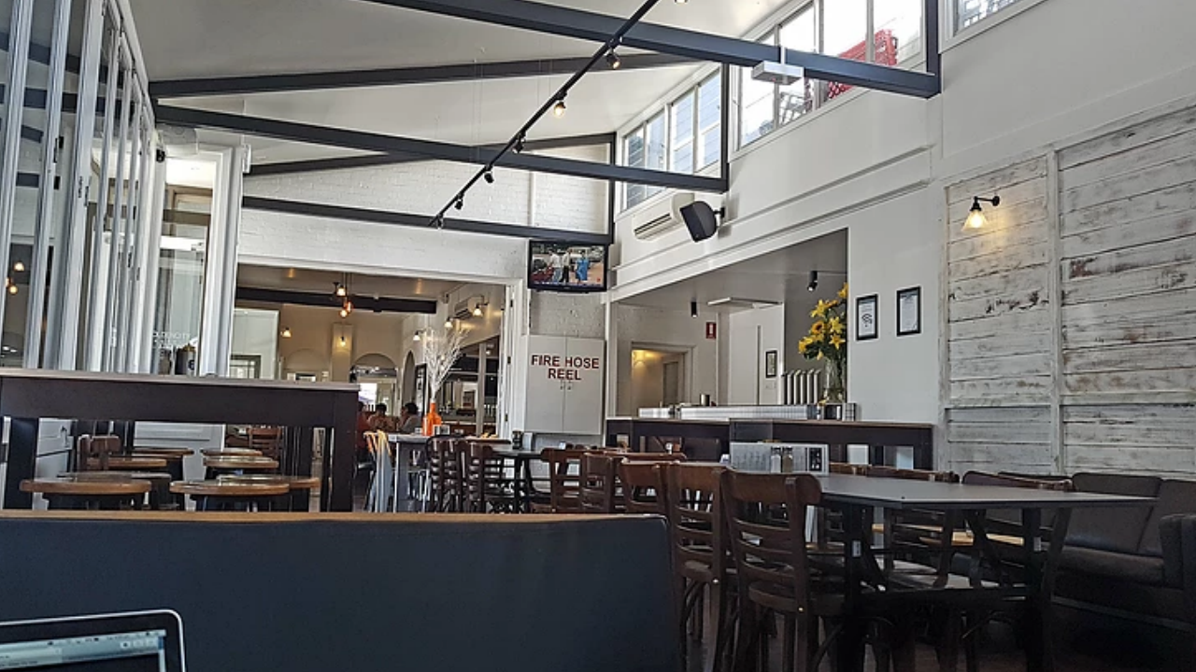

The ideal room for smaller functions. The bi-fold windows which open up onto Dawson St make this room very appealing during the warmer months. It has a bar and the capacity to hold up to 100 guests.

What is included:
- Complete privacy from other patrons
- Full access to room and street-side areas
- Professional bar/wait staff for your event
- Your selection of food & bar delivered to your expectations
- AV equipment and additions required
- Set up and clean up provided

These rooms offer great ambience and privacy for your event with our goal to make all guests comfortable and relaxed so that the experience can be truly enjoyed and remembered by all attending.

Please see over for the Menu options available for your event and we will be pleased to outline a clear quote for your function to further meet your budget and expectations.

Thank you for choosing The Golden City Hotel Ballarat for your experience.

For any further enquiry or to confirm your booking please call Rachel on (03) 53316211 or
Email: functions@goldencityhotel.com.au

CANAPÉS
$5 per canape with a minimum order of 25 per option

- Fresh Oysters – Natural or Mignonette
- Smoked salmon & pesto bruschetta with lemon crème fraiche
- Tomato & Goats Cheese bruschetta
- Fillet of beef with honey and sesame seeds (GF)
- Potato Spun Prawns
- Pork spring rolls with Asian green & hoi sin sauce (GF)
- Chicken & avocado on garlic & herb bread
- Smoked salmon & asparagus spears (GF)
- Tomato, Basil and Mozzarella Arancini Balls (V)
- Eton Mess
- Chocolate Mousse

FORK FOOD
$8 per fork with a minimum order of 25 per option

- Mini Tacos
- Mini Souvlakis
- Sliders
- Pumpkin and Chickpea Curry
- Fish & Chips
- Risotto (of the day)

COCKTAIL MENU
$16.00 pp (5 pces pp) or $25.00 pp (8 pces pp)
Choose 5 selections from below options:

- Party pies
- Sausage rolls
- Sweet chilli chicken tenders
- Calamari rings
- Vegetarian spring rolls (V)
- Mini quiche (vegetarian or bacon)
- Mini dim Sims
- Baby tempura Whiting fillets
- Spinach and ricotta rolls (V)
- Prawn money bags
- Chicken Satay Skewers
- Buffalo Wings

PLATTERS
20 persons per platter

- Sandwich platter $60
- Dips, bread & crackers platter $60
- Seasonal fruit platter $70
- Cheese platter $70
- Antipasto Platter $85
- Asian combination platter $70
- Tapas platter $85
- Crumbed seafood platter $85
- Dessert platter $65

**Gluten free breads are also available at extra cost.

PIZZA PLATTERS
15 persons per platter
MARGHERITA $60
Basil, sea salt, cracked pepper, mozzarella on a tomato base

HERB & GARLIC PIZZA $60
Garlic butter, mozzarella & herbs
TROPICAL $65
Tomato base, shaved leg ham, pineapple & mozzarella
VEGETARIAN $65
Pumpkin base, mozzarella, eggplant, red capsicum, artichokes, mushroom & spinach
BBQ CHICKEN $75
BBQ Base with chicken, red onion, bacon, mushrooms & mozzarella
PROSCIUTTO PIZZA $70
Napoli sauce, sliced prosciutto, mushrooms, mozzarella & rocket
PUMPKIN $65
Pumpkin base with bacon, feta, pine nuts

GLUTEN FREE BASE $10 extra per platter

Our aim is to make the variety of selections accommodating to tastes and diets for your guests. We are flexible in our offerings, so please feel free to discuss any additional selections or needs with us.

Your Menu options are designed for your best value of budget and also aiding our kitchen and staff in providing the highest quality for your occasion so please be open to working with us through this process.

Thank you for your consideration.

WHOLE CAKE PRICE LIST

Please note these prices are set for cakes to be sold whole at the standard size. Any variations, other cakes or special requests will be quoted as requested. * A minimum surcharge of $10 applies for personalized cake decorations
$60
Honeycomb Cheesecake
Mars bar Cheesecake
Chocolate Mud Cake
Choc Ripple Cake
Lemon Meringue Pie
$50
Lemon Cheesecake
Lemon & Lime Cheesecake
$45
Pav Roll
$55
Lemon Tart
Sponges
Sponges with fresh strawberries and cream
Small Round Sponge (serves 12) - $35
Large Round Sponge (serves 30-35) - $55

BALCONY BARBEQUE
*Minimum guests 35pax

Standard Barbecue Menu
@ $ 32.00 per person

Your choice of:

Two gourmet meats
- Two Salads
- One Side
- Served With a Selection of Fresh Breads and House Condiments

Dessert:
Assorted Mini Desserts

Selection BBQ options from List below:

Premium Barbecue Menu
@ $ 40.00 per person

Your choice of:

- Three gourmet meats
- Three Salads
- Two sides
- Served With a Selection of Fresh Breads and House Condiments

Dessert:
Assorted Mini Desserts & Fruit Platter

Meat Options
Beef Kebabs (+$2)
150g Scotch Fillet (+$2)
Chicken Skewers (+$2)
Lamb Chops (+$2)
Hamburgers
Lamb Rosemary Sausages
Vegetable Skewers (V)
Kofta Kebabs
Pork Spare Ribs
Buffalo Wings
Veggie Burgers (V)

Salads
Coleslaw
Potato & Chive Salad
Roast Vegetable & Pesto Pasta Salad
Golden City House Salad
Greek Salad
Rocket, Pear & Parmesan
Caesar Salad
Quinoa & Pumpkin Salad

Sides
Corn on the Cob
Grilled Onions
Garlic & Herb Mushrooms
Roast Baby Chat Potatoes

SET MENU OPTIONS
*Minimum guests 30pax
Set menus are available as one, two and three course options with a selection of two options per course for your menu based on a 50/50 alternate drop. Each menu is created to your functions needs and can provide an on the night ordering system, please discuss with the functions manager.
If you require catering for any allergies or dietary requirements we are happy to discuss alternatives.
ENTREES

Soup of the day (V) (GF) $9
Tomato & pesto bruschetta with a rocket & balsamic salad (V) (GF) $11
Wild mushroom & truffle risotto topped with homemade onion jam (V) (GF) $13
Spinach & pumpkin salad with cherry tomatoes red onion & toasted pine nuts (GF) $13
Smoked Salmon tartare with beetroot salad (GF) $15
Honey soy eye fillet with crispy bread (GF) $15
Crispy pork belly served on a Asian salad (GF) $14

MAINS

Grass fed eye fillet served with creamy mash, caramelised onion, honey glazed carrots and red wine jus $38

Spiced rubbed lamb rack (medium rare) served with roasted potatoes, steamed greens, house gravy and mint jelly $38

Twice cooked duck served on a bed of roasted root vegetables and five spice orange sauce $36

Grilled chicken breast served on top of a sweet potato mash, side of broccolini and a cherry tomato reduction $32

Char grilled vegetable lasagne served with a garden salad tossed in a Golden City house dressing $28

MAINS (CONTINUED)

8 hour slow roasted lamb or beef served with creamy mash, steamed greens and onion gravy $29

Grilled Atlantic salmon served with garden salad, chiplet and creamy capers sauce $33

Crispy Pork Belly served with roasted root vegetables, red wine sauce and apple chutney $30

DESSERTS

Eton Mess (GF) $9
Warm Chocolate Brownie with fresh cream $8
Lemon Tart $9
Chocolate Mousse $9

Cheese plate $12

The Business end of your function
We will endeavour to make all inclusions of quality and service our priority to your event and budget yet as in any business the details of quoting and conditions of use are required to make your event affordable, safe and enjoyable for all involved. The below outlined information will be incorporated into your quoted cost for your event but it is important that you re aware of these inclusions if your event falls under the required expenses below.
Room Hire and Deposit costs:

BALCONY
Monday-Thursday and Friday Day $150 room Hire
Friday Night No Room hire with $1000 minimum spend $250 dep required
Saturday Day No Room hire with $500 minimum spend $250 dep required
Saturday Night No Room hire with $2500 minimum spend $250 dep required
Sunday No Room hire with $500 minimum spend $250 dep required

AVIARY
Monday-Thursday and Friday Day $150 room Hire
Friday Night No Room hire with $1000 minimum spend $250 dep required
Saturday Day No Room hire with $500 minimum spend $250 dep required
Saturday Night No Room hire with $2500 minimum spend $250 dep required
Sunday No Room hire with $500 minimum spend $250 dep required

Peak Period costs apply from the last weekend of November through to 2nd January.
Additional costs are:
Monday – Sunday DAY - $150 room hire with no minimum spend
Sunday-Thursday nights $150.00 Room Hire with a $1000 minimum spend
Friday nights $250.00 Room Hire with a $2000 minimum spend
Saturday nights $250.00 Room Hire with $3000 minimum spend

*Room hire, food purchased, cake and all drinks are included in the minimum spend.

Please be aware that all catering orders and payments must be made two weeks prior to your function. Failure to do so will result in basic catering will be ordered on your behalf with an additional 5% surcharge added to your food cost.
Upon room hire payment, organisers acknowledge and accept the terms and conditions of room hire.
We are very excited to host your function and will strive to provide full satisfaction for your occasion with us. Please feel free to communicate any needs as they arise prior to your date and we look forward to serving you and your guests as requested.

Function Agreement Form

Name: _________________________________________________________________
Address: _______________________________________________________________
City: __________________________________________________________________
State: ________________ Postcode: ____________
Company: ______________________________________________________________
Contact Phone: _____________________________
Email: _________________________________________________________________
Room Booked: __________________________ Date of Function: _________________
Commencement Time: __________________________ Number of Guests: _________
Occasion (ie: 30th birthday, business meeting): _________________________________
Other notes: ____________________________________________________________

Credit Card Type (please circle): MasterCard Visa AMEX Diners

Name of Cardholder: ___________________________________________________________

Card Number: __ __ __ __/__ __ __ __/ __ __ __ __/__ __ __ __

Expiry: __ __/__ __ CCV: _______

We require full catering payment a minimum of one week prior to the function “NO REFUNDS”’

Signed: _________________________________________________________________
Please print name: _______________________________________________________
Date: _________________

Function Room Guidelines Conditions of Hire “Use”

Thank you for choosing to have your function at the Golden City Hotel. To ensure that your function is enjoyable, we ask that the following guidelines and conditions of use be adhered to.

- Persons under the age of 18 years may attend but cannot, by law, consume any alcohol on these premises, whether or not accompanied by a parent or guardian.

- The inside areas are to remain smoke free and provisions will be made on the balcony area only for smokers.

- In accordance with our Food Safety Plan no food items are to be brought onto the premises.

- Intoxicated and/or offensive behaviour will not be tolerated. Management reserves the right to refuse service and/or entry and to close down the function until individuals leave.

- No alcohol purchased outside the premises is to be consumed on the premises. Management will confiscate any BYO alcohol.

- Liquid and projectiles coming over balcony edge will not be tolerated. Persons found doing so will be kindly asked to leave.

- A deposit of $250 is required within 7 days of booking. – “No Refunds”

- Any changes to your function date must be made at least 8 weeks prior to your original date. Changes made within the 8 week period will forfeit the deposit.

- A minimum spend of $2500 is required for all functions in Balcony and Aviary on Saturday nights and minimum $1000 for a Friday nights. Catering for at least half of the guests attending is required to be purchased from the hotel and will be included in the minimum.

- For the month of December the minimum spend required is $2000 on a Friday night in both Balcony & Aviary and $3000 for Saturday nights in Adelphi & Zillies. Sunday to Thursday we require a minimum spend of $1000 for all functions in Adelphi & Zillies.

- All decorations are to be temporarily affixed. We ask that you use blu-tac, not sticky tape. Also no confetti or glitter or rice is to be used due to OH&S.

- For function purchases over $500 on card you will be charged a 1.5% surcharge.

- Damages – Any property or equipment damage caused by guest patrons will be invoiced at the cost of repair.

Our aim is to provide all patrons with a safe environment to be enjoyed by all. If our management feels that any of the above conditions are not being met, we reserve the right to close the function. Thank you for your co-operation.

BY SIGNING THIS FUNCTION AGREEMENT FORM I HAVE READ, UNDERSTOOD AND AGREE WITH ALL THE TERMS AND CONDITIONS OUTLINED IN THE FUNCTION PACK
Signed: ____________________________ Date: ___________ Print name: ____________________________________

